**The ERD image**

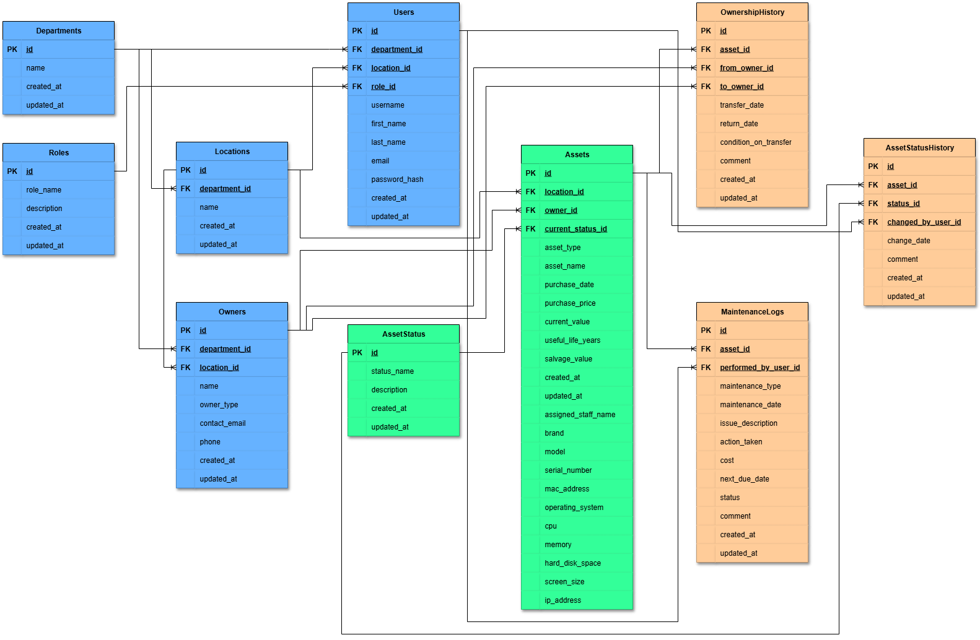

**A list of API endpoints**

| **Entity** | **Method** | **Endpoint** | **Description** |
| --- | --- | --- | --- |
| **Departments** | GET | /departments | List all departments |
| GET | /departments/{id} | Get department by ID |
| POST | /departments | Create a department |
| PUT | /departments/{id} | Update department |
| DELETE | /departments/{id} | Delete department |
| **Locations** | GET | /locations | List all locations |
| GET | /locations/{id} | Get location by ID |
| POST | /locations | Create location |
| PUT | /locations/{id} | Update location |
| DELETE | /locations/{id} | Delete location |
| GET | /departments/{id}/locations | Get locations in a department |
| **Roles** | GET | /roles | List all roles |
| GET | /roles/{id} | Get role by ID |
| POST | /roles | Create role |
| PUT | /roles/{id} | Update role |
| DELETE | /roles/{id} | Delete role |
| **Users** | GET | /users | List all users |
| GET | /users/{id} | Get user by ID |
| POST | /users | Create user |
| PUT | /users/{id} | Update user |
| DELETE | /users/{id} | Delete user |
| GET | /departments/{id}/users | Users in a department |
| GET | /locations/{id}/users | Users in a location |
| GET | /roles/{id}/users | Users with a role |
| **Owners** | GET | /owners | List all owners |
| GET | /owners/{id} | Get owner by ID |
| POST | /owners | Create owner |
| PUT | /owners/{id} | Update owner |
| DELETE | /owners/{id} | Delete owner |
| GET | /departments/{id}/owners | Owners in a department |
| GET | /locations/{id}/owners | Owners in a location |
| **Assets** | GET | /assets | List all assets |
| GET | /assets/{id} | Get asset by ID |
| POST | /assets | Create asset |
| PUT | /assets/{id} | Update asset |
| DELETE | /assets/{id} | Delete asset |
| GET | /locations/{id}/assets | Assets in a location |
| GET | /owners/{id}/assets | Assets owned by an owner |
| GET | /users/{id}/assets | Assets linked to a system user |
| **OwnershipHistory** | GET | /ownership-history | List all ownership records |
| GET | /ownership-history/{id} | Get ownership record by ID |
| POST | /ownership-history | Create ownership record |
| PUT | /ownership-history/{id} | Update ownership record |
| DELETE | /ownership-history/{id} | Delete ownership record |
| GET | /assets/{id}/ownership-history | History for an asset |
| GET | /owners/{id}/ownership-history | Transfers involving an owner |
| **MaintenanceLogs** | GET | /maintenance-logs | List all maintenance logs |
| GET | /maintenance-logs/{id} | Get maintenance log by ID |
| POST | /maintenance-logs | Create maintenance log |
| PUT | /maintenance-logs/{id} | Update maintenance log |
| DELETE | /maintenance-logs/{id} | Delete maintenance log |
| GET | /assets/{id}/maintenance-logs | Logs for an asset |
| GET | /users/{id}/maintenance-logs | Logs performed by a user |
| **AssetStatus** | GET | /asset-status | List all statuses |
| GET | /asset-status/{id} | Get status by ID |
| POST | /asset-status | Create status |
| PUT | /asset-status/{id} | Update status |
| DELETE | /asset-status/{id} | Delete status |
| **AssetStatusHistory** | GET | /asset-status-history | List all status history records |
| GET | /asset-status-history/{id} | Get status history by ID |
| POST | /asset-status-history | Create status history record |
| PUT | /asset-status-history/{id} | Update status history record |
| DELETE | /asset-status-history/{id} | Delete status history record |
| GET | /assets/{id}/asset-status-history | Status changes for an asset |
| GET | /users/{id}/asset-status-history | Changes made by a user |